**Black-Hole Image Generator**

Team 1: 黃朝宗

**Motivation:**

For the M87 black hole image, most of the DFT coefficients are interpolated by digital processing; therefore, it can also look very different if we choose different reconstruction methods. In particular, the ring structure could disappear for some cases. In this project, we aim to 1) generate realistic black-hole images by ourselves and 2) study the reliability of the ring structure.

**Approach:**

First, we will identify the captured DFT coefficients based on the published telescope coverage. Second, we will devise one or two reconstruction methods for filling missing coefficients. Third, we will perform extensive experiments with different system parameters to measure the reliability of the ring structure.

**Potential Issue:**

Since too many coefficients are not available, it may require advanced algorithms for the reconstruction. Our backup plan is to adopt the well-known CLEAN algorithm [1].

**Preliminary Result:**

We have analyzed the real resolution of the published image as below and found that it is 32x scaled up. We also identified the captured DFT coefficients and are now ready to develop our own reconstruction method.

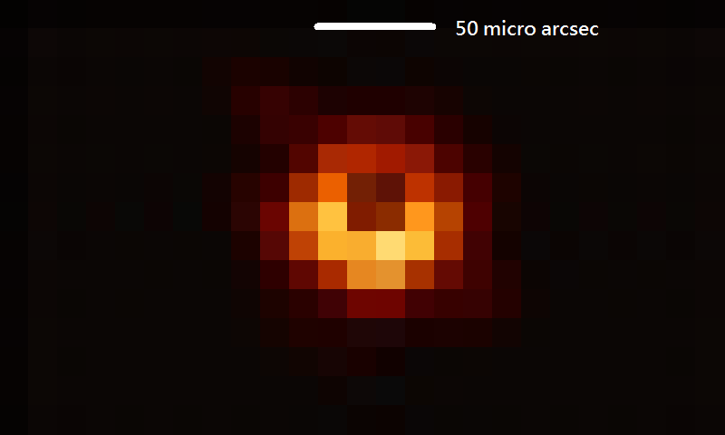

**Software:**

MATLAB and related toolboxes.

**Reference:**

[1] https://en.wikipedia.org/wiki/CLEAN_(algorithm)